[E143] WIFI module

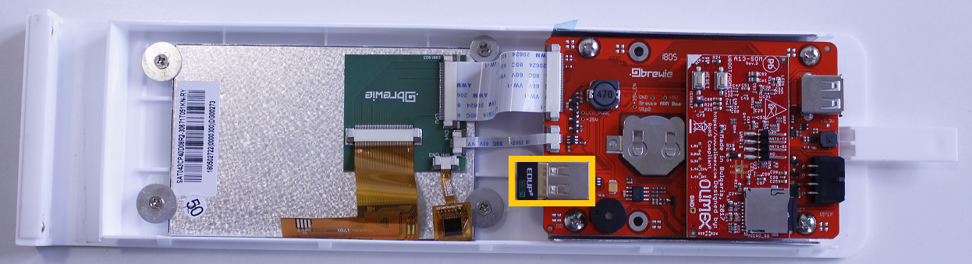

The WIFI module is located in the front panel assembly plugged in the ARM module.

Check [E119] about how to remove the front panel from the B+.

The WIFI module is connected via USB to the panel. Simply pull off the WIFI stick and replace it with a new one.

